
RAMAIAH
INSTITUTE OF TECHNOLOGY
USN | 1 | M | S

(Autonomous Institute, Affiliated to VTU)
(Approved by AICTE, New Delhi & Govt. of Karnataka) Accredited by NBA & NAAC with ‘A’ Grade

SUPPLEMENTARY SEMESTER EXAMINATIONS – JULY/AUGUST 2018

Course & Branch | : | B.E. : Electrical and Electronics Engineering | Semester | : | V
Subject | : | Advanced Industrial Automation - I | Max. Marks | : | 100
Subject Code | : | EEPE34/EEE02 | Duration | : | 3 Hrs

Instructions to the Candidates:
- Answer one full question from each unit

 |  | UNIT- I
1. | a) | Define the following terms:  - Scan time ii. Thermopile iii. Thermistor. | CO1 | (09)
 | b) | Draw the ladder Diagram for the multiplexer that will take one of four inputs bits D1, D2, D3 or D4 and make it the output X, depending upon the values of the address bits, A1 and A2.  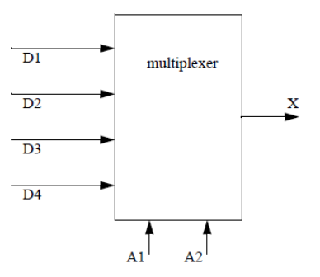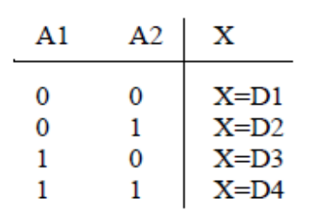 | CO1 | (06)
 | c) | Explain in detail the term “Processor Scan”. | CO1 | (05)
2. | a) | With a neat diagram explain the working principle of turbine flow meter. | CO1 | (08)
 | b) | Explain in detail Linear Variable Differential Transformer. | CO1 | (08)
 | c) | Draw a ladder diagram that will cause output D to be ON when push button A is ON, or either B or C areON. | CO1 | (04)
 |  | UNIT- II
3. | a) | With a block diagram explain the direct action I/O interface module. | CO2 | (08)
 | b) | List out the factors to be considered while selecting an input module. | CO2 | (08)
 | c) | Mention the typical analog input interface ratings. | CO2 | (04)
4. | a) | An input module, which is connected to a temperature transducer, has an A/D with a 10-bit resolution. When the temperature transducer receives a valid signal from the process (0-300 ºC), it provides, via a transmitter, a 0 to +5 VDC signal compatible with the analog input module. Find the equivalent the voltage change per ºC change and the equivalent number of counts per ºC. | CO2 | (07)
 | b) | Describe in detail the Wire input Fault Module. | CO3 | (08)
 | c) | List out the rules governing the development of ladder diagram. | CO2 | (05)
 |  | UNIT- III
5. | a) | Develop the ladder logic diagram to satisfy the following requirements  - As the PB1 is pressed, MV1 opens and the water begins to fill the tank. At the same time stirring motor M starts operations  - When the water level passes TLB2 and reaches TLB1, the MV1 closes and stirring motion stops  - Next, MV2 opens and starts draining the water. When the water level drops below TLB2, MV2 closes.  - When the cycle of operation has repeated four times, the operation END indicator illuminates, and the filling and draining operation will not restart even if PB1 is pressed.  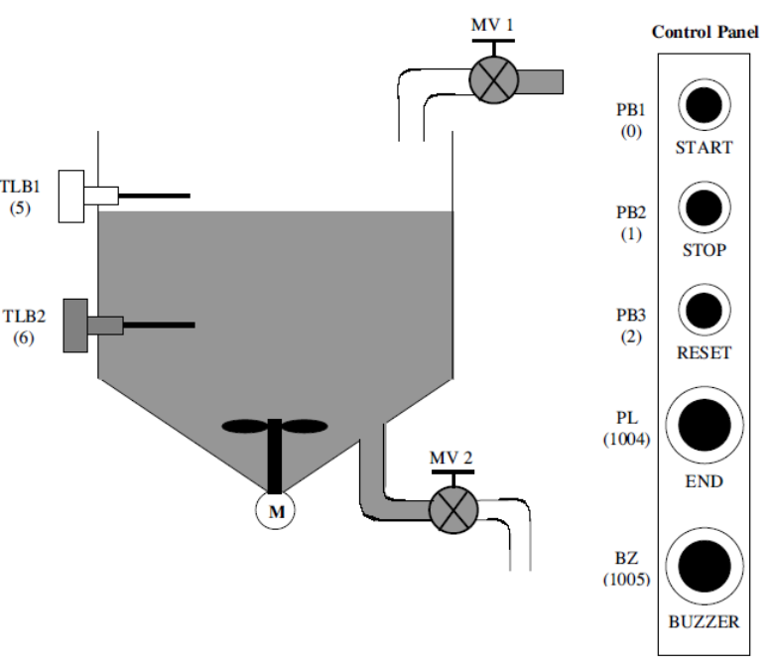 | CO3 | (10)
 | b) | Using Twido Suite software instructions design a conveyor control system that follows the design guidelines below.  - The conveyor has an optical sensor S1 that detects boxes entering a workcell  - There is also an optical sensor S2 that detects boxes leaving the workcell  - The boxes enter the workcell on a conveyor controlled by output C1  - The boxes exit the workcell on a conveyor controlled by output C2  - The controller must keep a running count of boxes using the entry and exit sensors  - If there are more than five boxes in the workcell the entry conveyor will stop  - If there are no boxes in the workcell the exit conveyor will be turned off  - If the entry conveyor has been stopped for more than 30 seconds the count will be reset to zero, assuming that the boxes in the workcell were scrapped. | CO3 | (10)
6. | a) | Develop a ladder program using twidosuite instructions that will latch on an output B, 20 seconds after input A has been turned on. The timer will continue to cycle up to 20 seconds, and reset itself, until input A has been turned off. After the third time the timer has timed to 20 seconds, the output B will be unlatched. | CO3 | (08)
 | b) | Using Twido suite instruction set develop a ladder diagram to achieve the following specification:  A buffer can hold up to 10 parts. Parts enter the buffer on a conveyor controller by output conveyor. As parts arrive they trigger an input sensor enter. When a part is removed from the buffer they trigger the exit sensor. Write a program to stop the conveyor when the buffer is full, and restart it when there are fewer than 10 parts in the buffer. As normal the system should also include a start and stop button. | CO3 | (08)
 | c) | Explain the functions of the following instructions:  - Shift ii. Rotate. | CO3 | (04)
 |  | UNIT- IV
7. | a) | Write a short note of system documentation. | CO4 | (14)
 | b) | What are the advantages of wire labeling? | CO4 | (06)
8. | a) | Explain the process of troubleshooting PLC inputs. | CO4 | (10)
 | b) | Explain the impact of excessive noise on the PLC system. | CO4 | (06)
 | c) | Define: Wire Bundling. | CO4 | (04)
 |  | UNIT- V
9. | a) | Define the following terms with respect to SCADA:  - Scalability ii. Redundancy. | CO5 | (08)
 | b) | Write a short note on MMI. | CO5 | (08)
 | c) | Define trending. | CO5 | (04)
10. | a) | What are the functions of Master Station? Explain. | CO5 | (08)
 | b) | Draw the diagram of the architecture of RTU. | CO5 | (06)
 | c) | What are smart instruments? Explain. | CO5 | (06)

****************

